ANNUAL REPORT

S.N.M. MEMORIAL EDUCATIONAL FOUNDATION

Address : 374 B, Ashok Nagar, Road no-4, PO+PS-Argora,
Dist-Ranchi, Jharkhand, Pin-834002

ANNUAL PROGRESS REPORT YEAR 2025-26

S.N.M. MEMORIAL EDUCATIONAL FOUNDATION

ANNUAL PROGRESS REPORT YEAR 2025-26

INTRODUCTIONS :

S.N.M. MEMORIAL EDUCATIONAL FOUNDATION is founded by
the antiseptic social leaders, educationalist and village/community leaders of the area sustainable development in trial’s slums and helpless women and children of different area of Jharkhand by providing opportunity through socio economic development, social justice and health awareness program. The organization is formally registered under Trust registration Act. 1882, bearing, Reg. No Reg. Dated 14.08.2010

The organization is working mainly in the urban and rural areas of Jharkhand state.

OBJECTIVES :

- To work on prevention, awareness, early identification, diagnosis, vocational training, education & training, and all other welfare work for different disabilities.
- To obtain technical employment and training support by networking with the existing national and state level institutions or through establishment or new ones.
- To establish new school i.e., play, nursery, primary, middle & High schools, colleges and non-profit universities/ organizations based on different streams, modes, patterns, methods, specifications etc.
- To provide higher and technical education in both urban and rural area. Technical education like typing, computer training and establish regular school, library night school, adult education and with other specialties.
- The objects of the society is to provide for the educational requirements of the citizens, and to impart law education technical education in particulars .
- To establish, start, aid, run, maintain or manage C.B.S.E Board, libraries, technical, professional etc. for expansion and development of law educational college in Jharkhand.
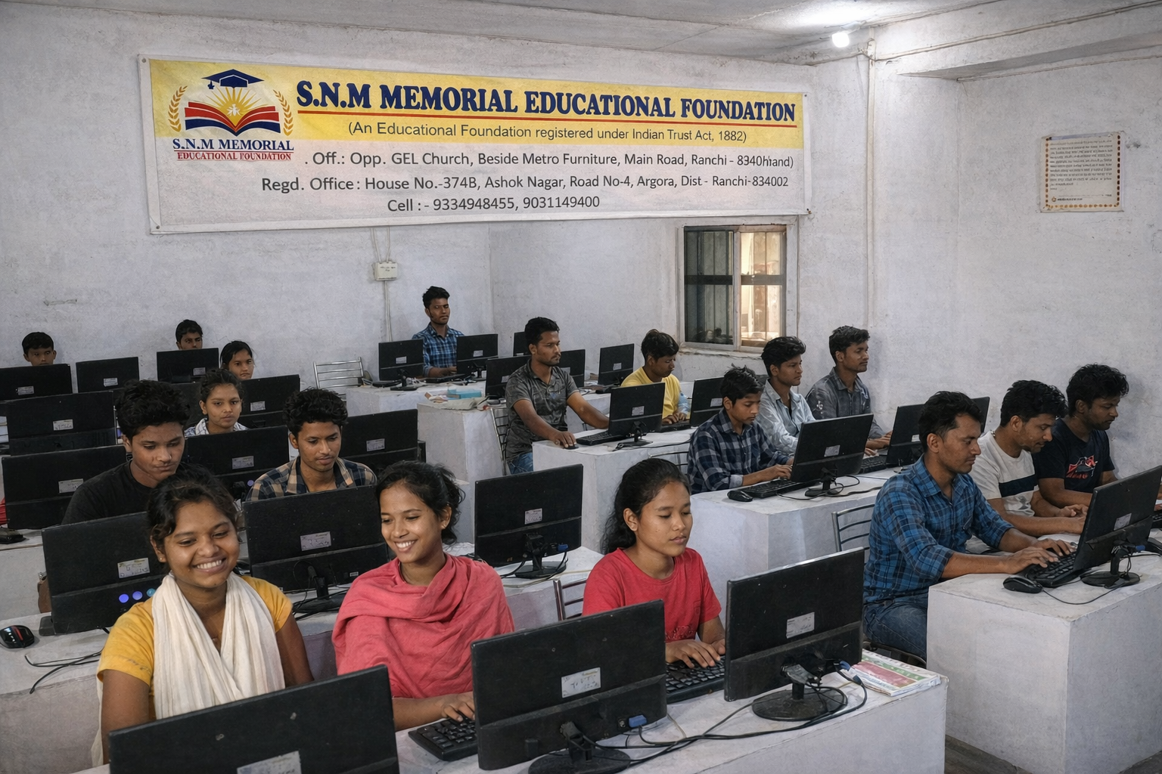

- Whenever possible in the educational institutions, to establish funds and scholarships for the educational benefits of poor and needy students.
- To diffuse knowledge moral, religious, social and technical.

- We have been working in the field of HIV/AIDS, Hepatitis B, Pulse Polio etc. and other awareness programme in different district of Jharkhand state.
- Socio economic and political empowerment of tribal and backward communities.

- Non formal and adult education programme among illiterate people of various areas of Jharkhand.
- Establishment of small scale industries i.e. sewing, knitting, embroidery and handicraft

etc. for women of rural and urban areas of Jharkhand.  - Environment protection through plantation and awareness programme | amongst | the
rural masses.  - Sustainable agricultural development in the rural areas through proper | irrigation

facilities, farmers training and use of improved and appropriate seed varieties.
- We have been working in the field of Awareness programme on Health & Eye Check-up Camps.

  - This organization provide Awareness programme on Education for Computer literacy.
  - We have been working to programs on Sports Activities and Administrative and other misc.
  - For the protection of Environment we work to programme on Pollution Control.

  - To work for women security, cultural social, spiritual and ideological thoughts; spread brotherhood, equality, humanity and work against corruption, poverty, nasals, dowry, social evils, liquor, human trafficking
  - To work for the promotion and development of agriculture-cultivation of medicinal plants, biological farming, plantation, irrigation, horticulture, sericulture, floriculture and related fields.
  - To work for development of Sanitation, Cleanness, personal development, Education and training, Self employment , Tribal welfare in the state. To provide to the needy physically handicapped personal aids and appliances that can promote their physical rehabilitation and to promote research on aids and appliances for the disabled.
  - To organize sports, cultural programs seminars, fairs, group discussions , debates, awareness campaigns, health camps, etc. by own or with any individual, organization, state or central Gov.
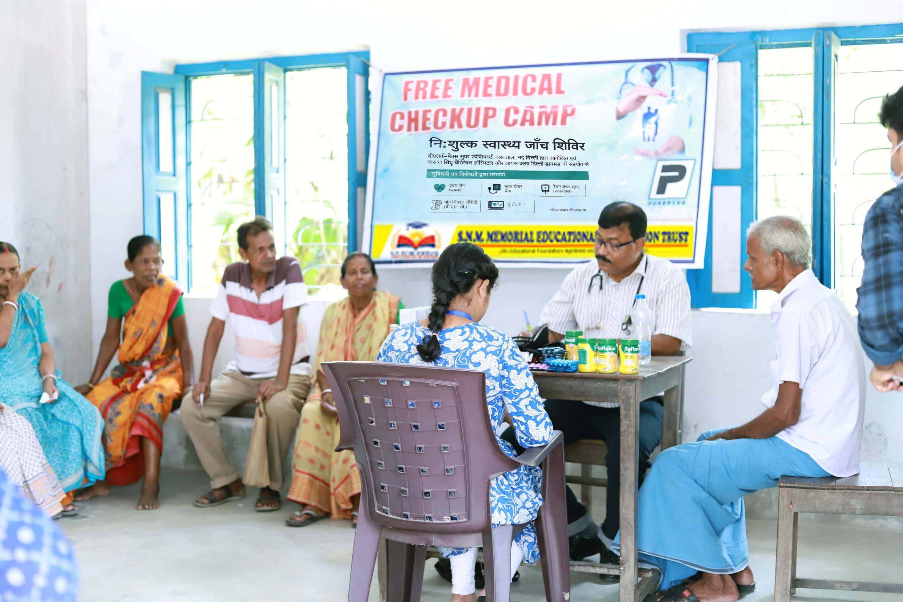

  - To promote and carry out, on its own or on behalf of the State Government, activities to generate awareness, research and study on the issues relating to Skill Development Especially school drop outs, frescoed, child labor and all other disadvantaged groups.
  - To register vocational training providers in uncovered areas particularly rural and backward areas and to provide necessary funds to them.
  - To provide knowledge of non-conventional energy and to train the people in this environment.
  - To organize sports, cultural programs seminars, fairs, group discussions , debates, awareness campaigns, health camps, etc. by own or with any individual, organization, state or central Gov.
  - To do all measures, to promote, flourish all types of animal ; husbandry and dairy business.
  - To promote and organize cultural activities by organizing several cultural events in villages and urban areas.

  - To promote tribal and local cultures in cities inside and outside the States.
  - Debate, seminars and Drama among educated youth of the District.
  - To create duly empowered administrative mechanisms through such participation as May deemed necessary, for the achievement of the objects of the Society.
  - To bring likeminded social worker together to encourage people for social art and culture.

  - To teach theatre, art & craft, culture & literature to the needed and poor children across the country.
  - To work on prevention, awareness, early identification, diagnosis, vocational training, education & training, and all other welfare work for different disabilities.
  - To obtain technical employment and training support by networking with the existing national and state level institutions or through establishment or new ones.
  - To render medical services by opening medical dispensaries, hospitals, medical care centers etc and organizing medical camps and to render such medical serves to the people which may be necessary from time to time and place to and place to place.

ACTIVITIES IMPLANTED DURING THE YEAR 2025-26
Women empowerment:
The organization is trying to develop socio- economic and political status of the tribe’s and backward masses by organizing a group known as the (SHGS) which is working for the empowerment of women. The group is providing sewing machines and craft item to the women for self help. The SHGS is also working for different others purposes.
Our organization has provided wheelchairs to the handicapped and distributed books, copies and stationeries to the poor children of the villages. SHGS provides herbal training in the fields of Mushroom plantation.
- ENVIRONMENTALAWARENESS PROGRAMMES :

Environment awareness program is organized in Ranchi district. In the program people from about 10 adjunct villages get participated. Resource persons delivered their lectures on advantage of forest protection of environment and drawback of defender station land and forest in the area. Rural people were advised to save the jungle and replant in the degraded barren land, upland.
  - The SHGS is trying to support the poor masses by providing (economical) help to meet their urgent needs.
  - Theirs organization (S.N.M. MEMORIAL EDUCATIONAL FOUNDATION) is sum by members through self contribution.

CONCLUSION :
On behalf of the organization would like to thank all my
committee and staff members for their cooperation and for their participation and support.

We are also thankful to the village of Jharkhand for their sincere participation in the field of rural development.

May God bless us with better tomorrow!

Secretary

